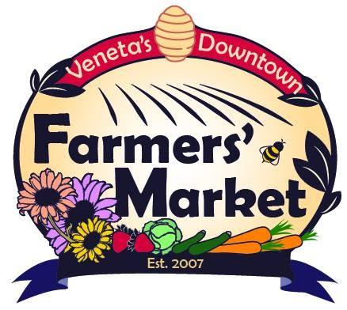

Veneta Downtown Farmers Market Vendor Application 2022
May 7 through Oct 22 10:00 AM to 2:00 PM

I wish to reserve booth space at Veneta Downtown Farmers Market (VDFM). I understand I will be reserving booth space of 10 feet by 10 feet. A non-refundable annual membership fee for food producers ($25) and for artisans and non-profits ($10) is due at the time of application approval.
Weekly booth fees are $15.00 per Saturday with an additional 3% of gross sales over $150.00.

I understand I may request a specific space location, but space assignments are first come, first served and at the discretion of the Market Director. Vendors will remove all garbage and leave space clean. Vendor will be responsible to always maintain personnel for their vendor space. I understand that all Rules and Regulations outlined will be followed and lack of compliance will result in voiding this agreement and participation in the VDFM,without refund of membership or booth fees. The market will occur rain or shine. Please be set up by 9:45 AM, and plan to stay until 2:00 PM. Early breakdown is not permitted. Load-in and load-out is on West Broadway & 3rd street, as well as limited drive-in (manager approved) to the site. These areas are for loading purposes only. All vehicles must be moved to the east and west of the consumer parking by 9:55 AM

Name: ________________________________________________
Non- Profit Organization: ________________________EIN#: ______________________
Oregon Drivers License #______________
Vendor Name: ___________________________________________________________
Vendor Address: _________________________________________________________
Address where the majority of your products are grown/produced:
City: _________________________ Zip ______________
Phone#___________________________Email______________________________________
Vendor Signature: _______________________________________ Date: _________________
Discounts Applied________________ Payment______________

The Veneta Downtown Farmers Market, the City of Veneta, and the Fern Ridge Community Action Network take no responsibility for the actions of vendors. The Veneta Downtown Farmers Market, the City of Veneta, and the Fern Ridge Community Action Network will not be responsible for any loss incurred by the vendor.

Submit Applications as PDF files to: venetadfm@gmail.com

Questions?
The Market Director can answer, guide and direct your questions - on site, by email, or call 541-729-1877.

I hope & plan to attend the following markets
(Circle all that apply)

May | June | July | August | September | October
7 | 4 | 2 | 6 | 3 | 1
14 | 11 | 9 | 13 | 10 | 8
21 | 18 | 16 | 20 | 17 | 15
28 | 25 | 23 | 27 | 24 | 22
 |  | 30

Please be as detailed as possible and provide signage for products origins and certifications.
[ ] Produce Type: ______________________________________________
[ ] Plants Type: ______________________________________________
[ ] Flowers Type: ______________________________________________
[ ] Eggs Type: ______________________________________________
[ ] Meat Type: ______________________________________________
[ ] Other: Type: ______________________________________________
[ ] Other: Type: ______________________________________________

Please tell us about your growing practices:
[ ] Certified Organic Certification Company: ____________________________
[ ] Naturally Grown
[ ] Conventionally Grown
[ ] Wildcrafted/Collected
[ ] Animal Welfare Certified
[ ] Organically grown, not certified
[ ] Other: ___________________________________

Farm Food vendors will provide liability insurance where appropriate @ first market attending:
[ ]Liability Insurance Certificate naming Veneta Downtown Farmers Market as additional insured on policy

Please provide copies of all current licenses and certificates where appropriate:
[ ] Tilth Organic Certificate [ ] Temporary Restaurant License
[ ] Kitchen Certificate [ ] Nursery License
[ ] Contract for use of commercial kitchen [ ] OLCC Permit for wine/beer
[ ] Food Handlers Permit [ ] Dairy Processor’s License
[ ] Low Acid Certificate OSU [ ] Meat Sellers License
[ ] Scale Certificate [ ] Copy of lease on property if applicable
[ ] All applicable foraging and wildcrafting permits

[ ] I have read and agree to abide by the Veneta Downtown Farmers Market Rules and Regulations.

Signature of Vendor: ___________________________________ Date: ___________________________

